**PART A**

**EXPERIMENT NO. 3**

**A.1 AIM: -** To draw the behavioral view diagram: Activity diagram

**A.2 Prerequisite**

Determine the desired flow of action and their interaction with each other

**A.3 Outcome**

After successful completion of this experiment students will be able to -

1. Better understanding of the interaction diagrams.
2. Get familiar with Activity diagram
3. Practice drawing the interaction diagrams using StarUML

**A.4 Theory**

Activity diagrams are flow charts that are used to show the workflow of a system.

They also:

* Represent the dynamics of the system.
* Show the flow of control from activity to activity in the system.
* Show what activities can be done in parallel, and any alternate paths through the flow.

Activity diagrams may be created to represent the flow across use cases or they may be created to represent the flow within a particular use case. Later in the life cycle, activity diagrams may be created to show the workflow for an operation.

Activity diagram notations:

* Rounded rectangles represent activities

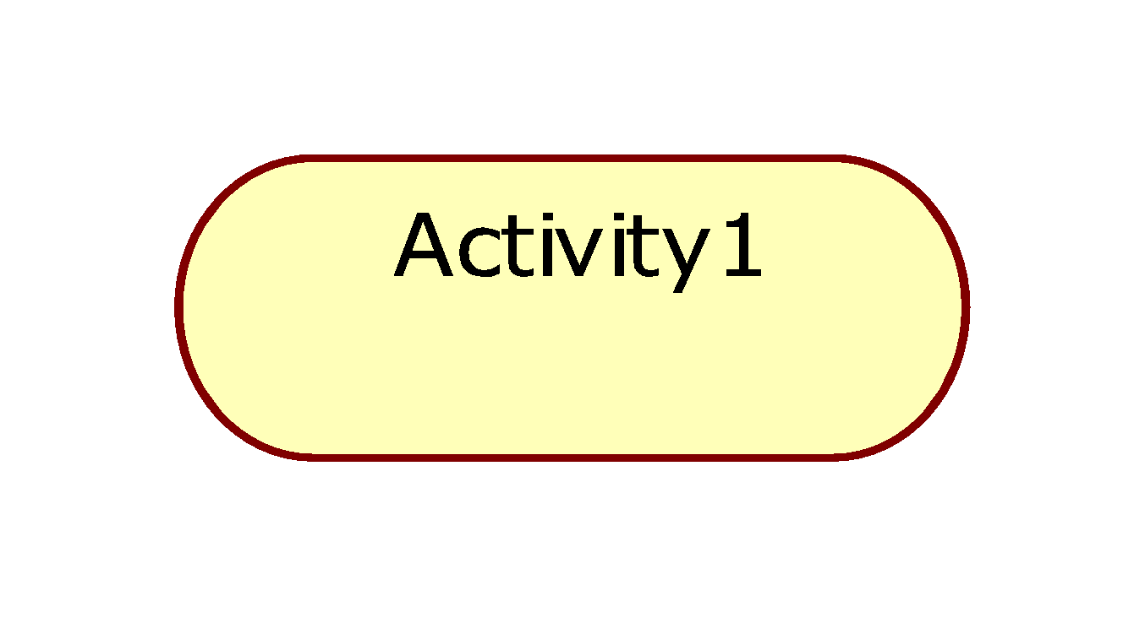

* Diamonds represent decisions

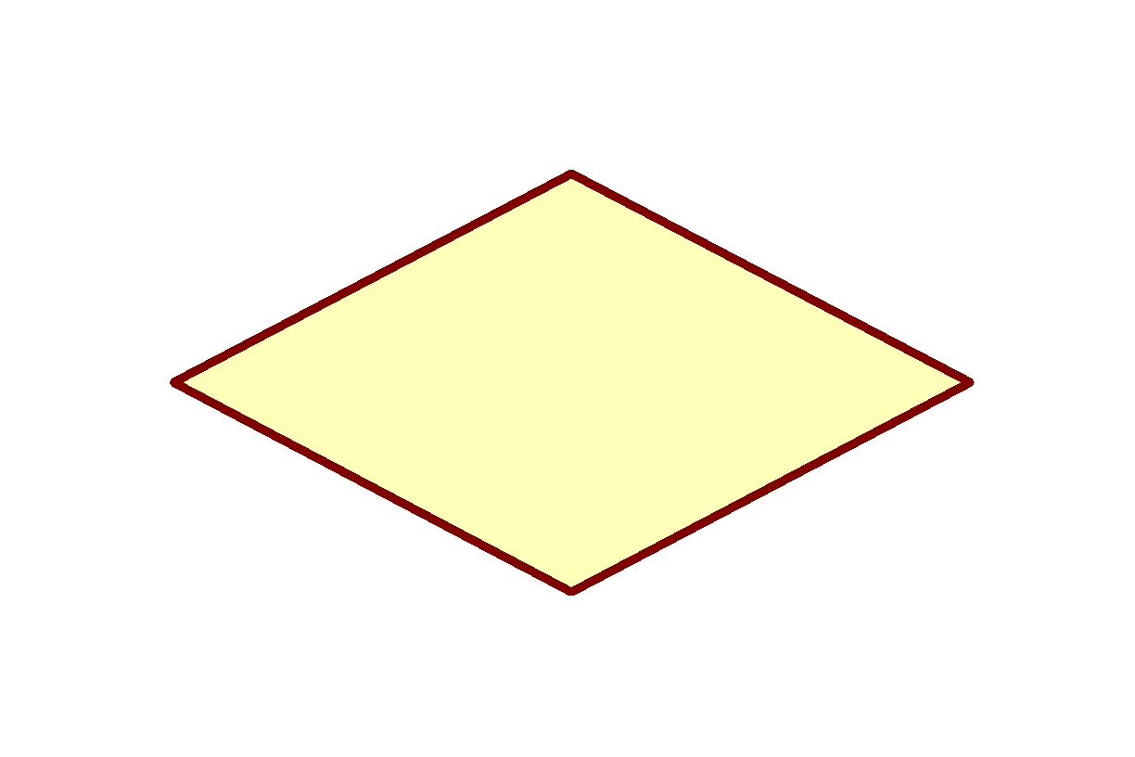

* A black circle represents the start (initial state) of the work-flow



* An encircled black circle represents the end (final state).



* Swimlane (vertical)
* Swimlane (horizontal): Swim lane- depicts which human organization is responsible for an activity. Organization – sales, finance, marketing, purchasing etc. Swim lane indicates that activity is performed by a person or persons within the organization.

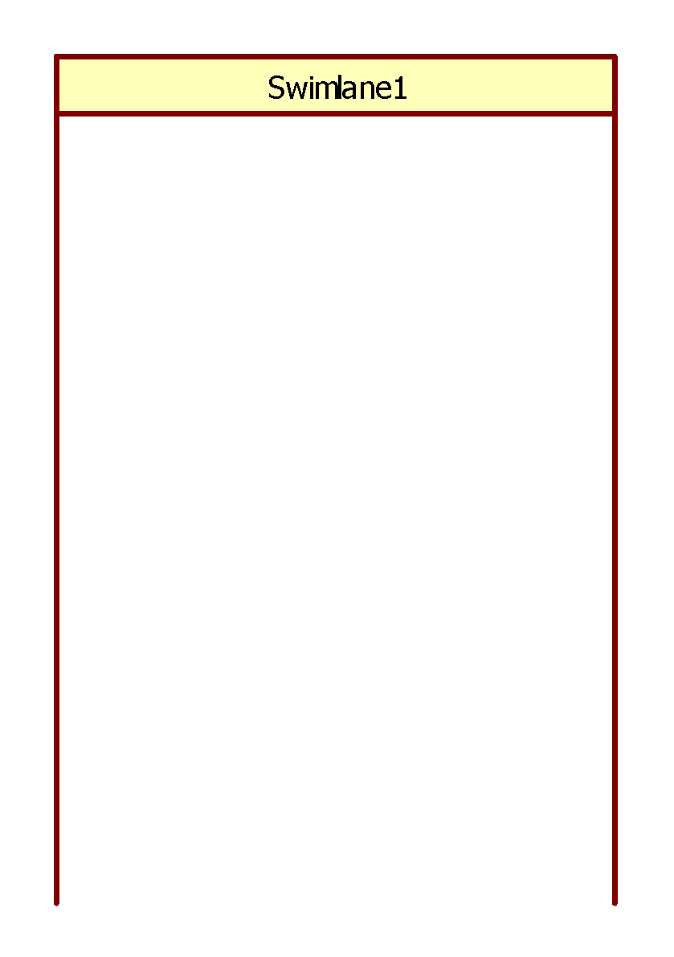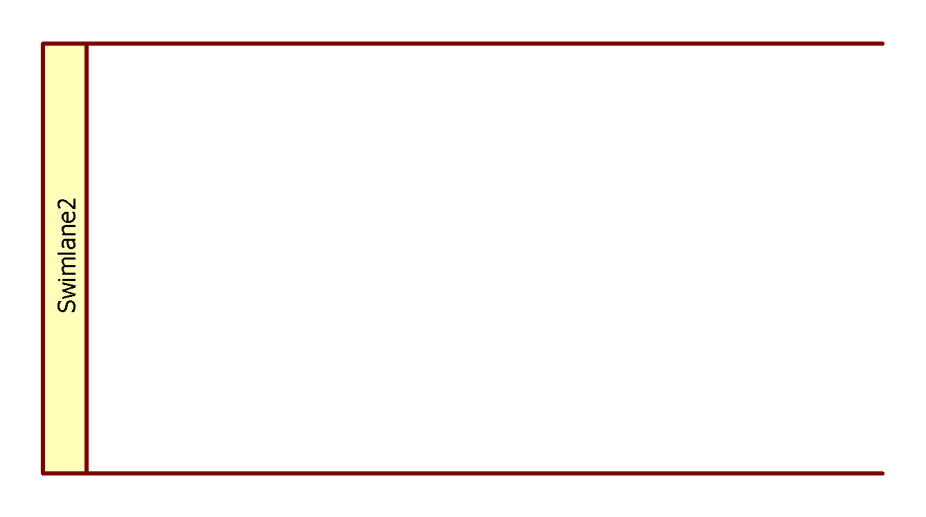

* Bars represent the start (split) or end (join) of concurrent activities

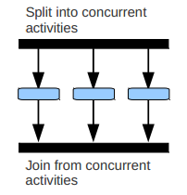

**Activity diagram for uploading photograph:**

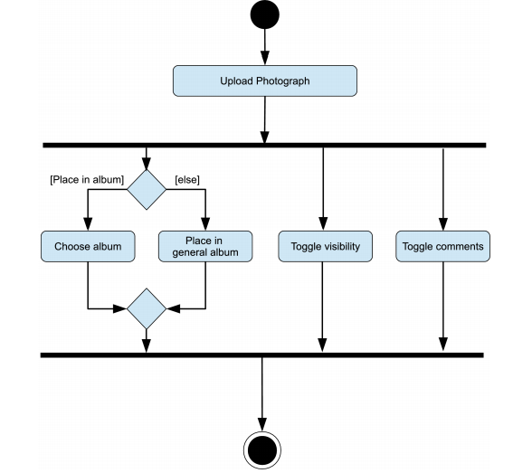

**Activity diagram for stock trading processing:**

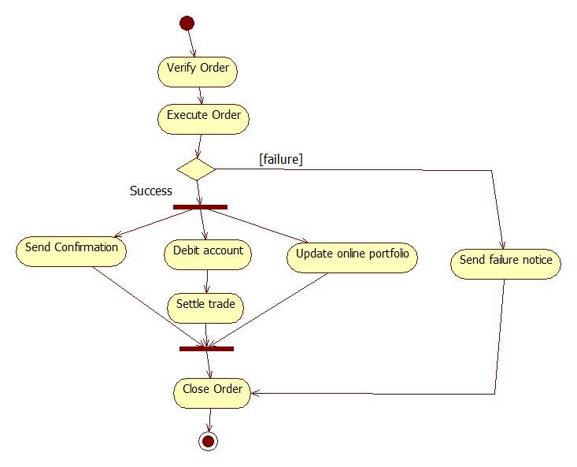

**Activity diagram using swimlane:**

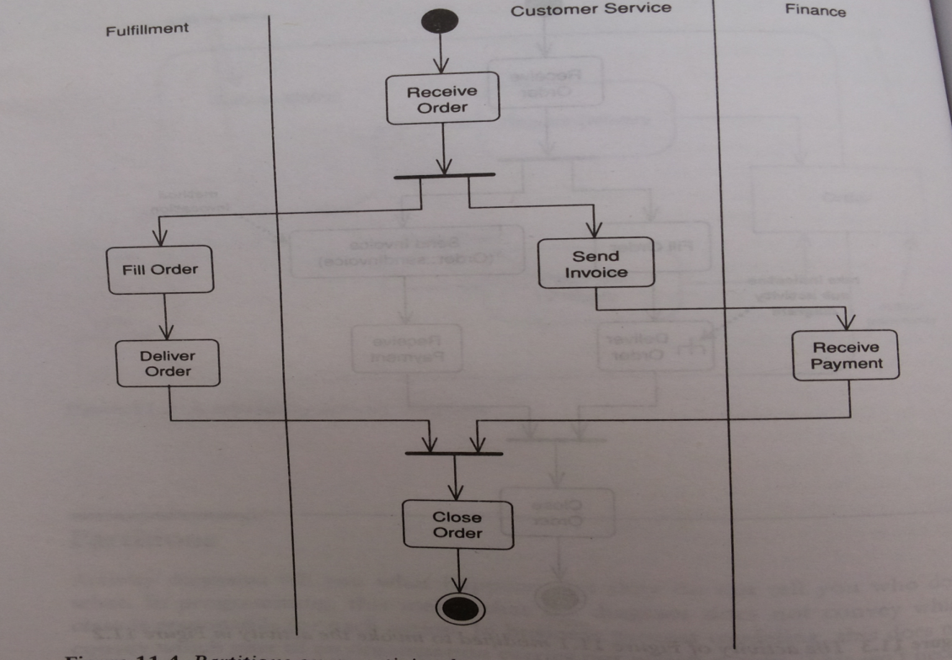

**A.5. Task:**

Draw an activity diagram for the case study.

**PART B**

(PART B: TO BE COMPLETED BY STUDENTS)

*(Students must submit the soft copy as per the following segments within two hours of the practicals. The soft copy must be uploaded on Blackboard LMS or emailed to the concerned Lab in charge Faculties at the end of practical; in case Blackboard is not accessible)*

|  |  |
| --- | --- |
| Roll No: C101 | Name: Samkeet Shah |
| Class: C | Batch: B3 |
| Date of Experiment: | Date of Submission: |
| Grade: |  |

**B.1 Activity diagram**

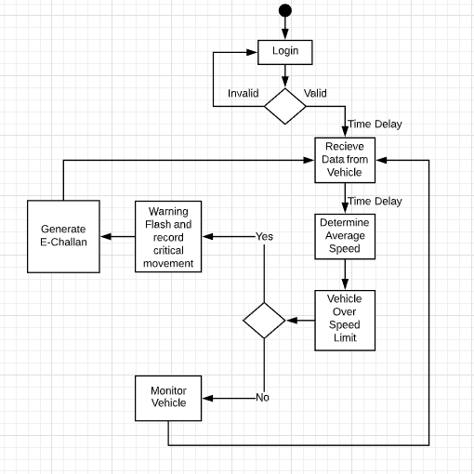

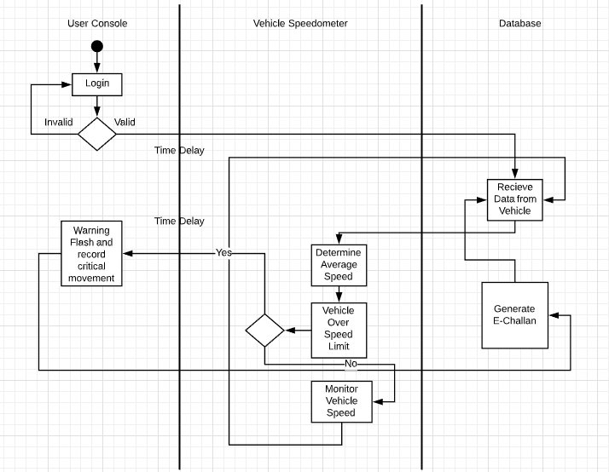

**B.2 Conclusion**

*(Students must write the conclusion as per the attainment of individual outcome listed above and project definition noted in section B.1 including “Define the System, Motivation, Scope of the System and Applications”)*

**B.5 Questions of Curiosity:**

Q1. What is the primary purpose of the activity diagram?

Sol. The basic purpose of activity diagrams is similar to the other four diagrams. It captures the dynamic behavior of the system. Other four diagrams are used to show the message flow from one object to another but activity diagram is used to show message flow from one activity to another.

Q.2 State the difference between branches and fork and join in the activity diagram.

Sol. A fork node is used to split a single incoming flow into multiple concurrent flows. It is represented as a straight, slightly thicker line in an activity diagram. A join node joins multiple concurrent flows back into a single outgoing flow. A fork and join mode used together are often referred to as synchronization.